**Practical 1**

**Aim: Basic Commands**

1. Write following commands in terminal

* ***ls***: This command is used to list all the files
* ***ls -a***: list all files along with hidden files
* ***cd*** Desktop/: change current directory to Desktop
* ***pwd***: get current directory
* ***mkdir*** sample_dir: create new directory named as given
* ***touch*** file.txt: creates given file
* ***rm*** file.txt: removes given file
* ***rm -r*** sample_dir/: removes given directory
* ***cp*** file.txt sample_dir/: copies a file to a given directory
* ***cp -r*** sample_dir/ sample_dir2/: create a copy of given directory
* ***mv*** file.txt file3.txt : moves to given directory or renames a file
* ***gedit*** file2.txt: creates a file and opens gedit editor for it
* ***cat*** file.txt*:* creates a file if not exist or displays file content
* ***cat*** file.txt file2.txt > file3.txt: concatenates files into another file as give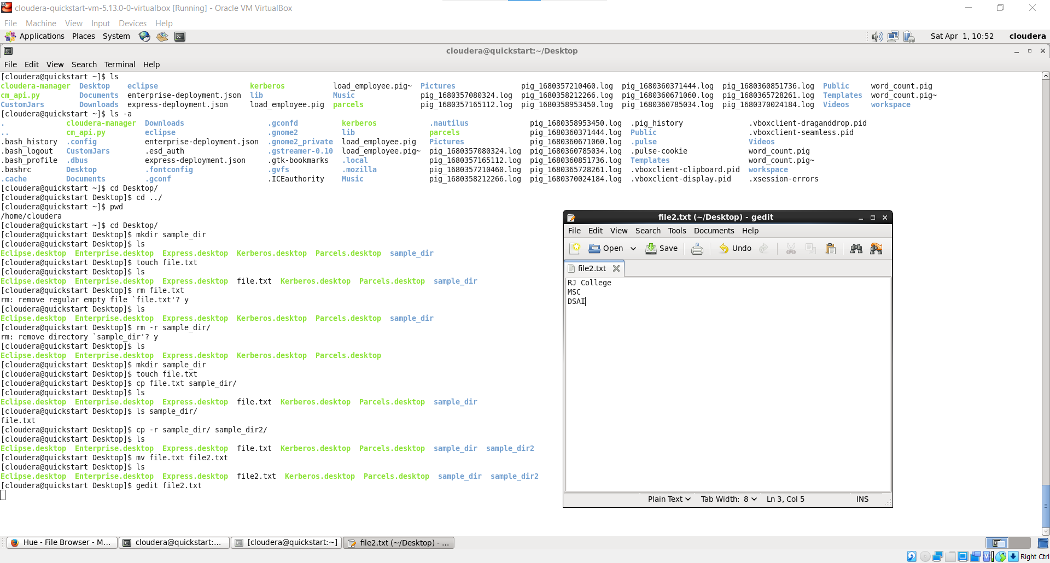

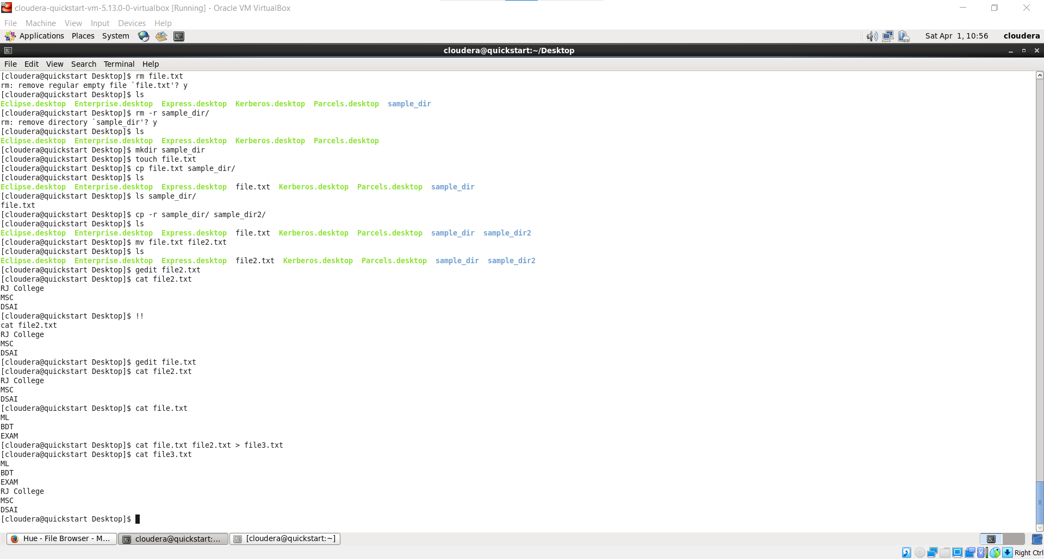

* hdfs dfs -***ls*** / : list files and directories of root
* hdfs dfs -***mkdir*** /sample_dir: create new directory current working directory
* hdfs dfs -***ls*** /input_dir : list all files under the given directory path
* hdfs dfs -***copyFromLocal*** file3.txt /sample_dir/: copies files or directory from the local filesystem to the destination in the Hadoop filesystem.
* hdfs dfs -***put*** file.txt /sample_dir/: copies files or directory from the local filesystem to the destination in the Hadoop filesystem.

